ANNOUNCEMENTS  - Oct. Breast Cancer Awareness  - Oct. 16 ~ LCIP 4th Quarter Steering Committee Meeting after regular service  - Operation Christmas Child – Shoe Box/Samaritan Purse – Yeuleta Bradley * Thank You! *  - Bible Study 9:30am Friday, Ephesians Chapter 6  - October is Pastor Appreciation Month  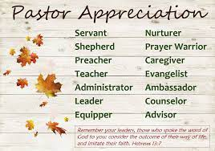  Fall for Jesus He is Truly Un Be Leaf Able |  |  | October 9, 2022  Little Church in the Pines  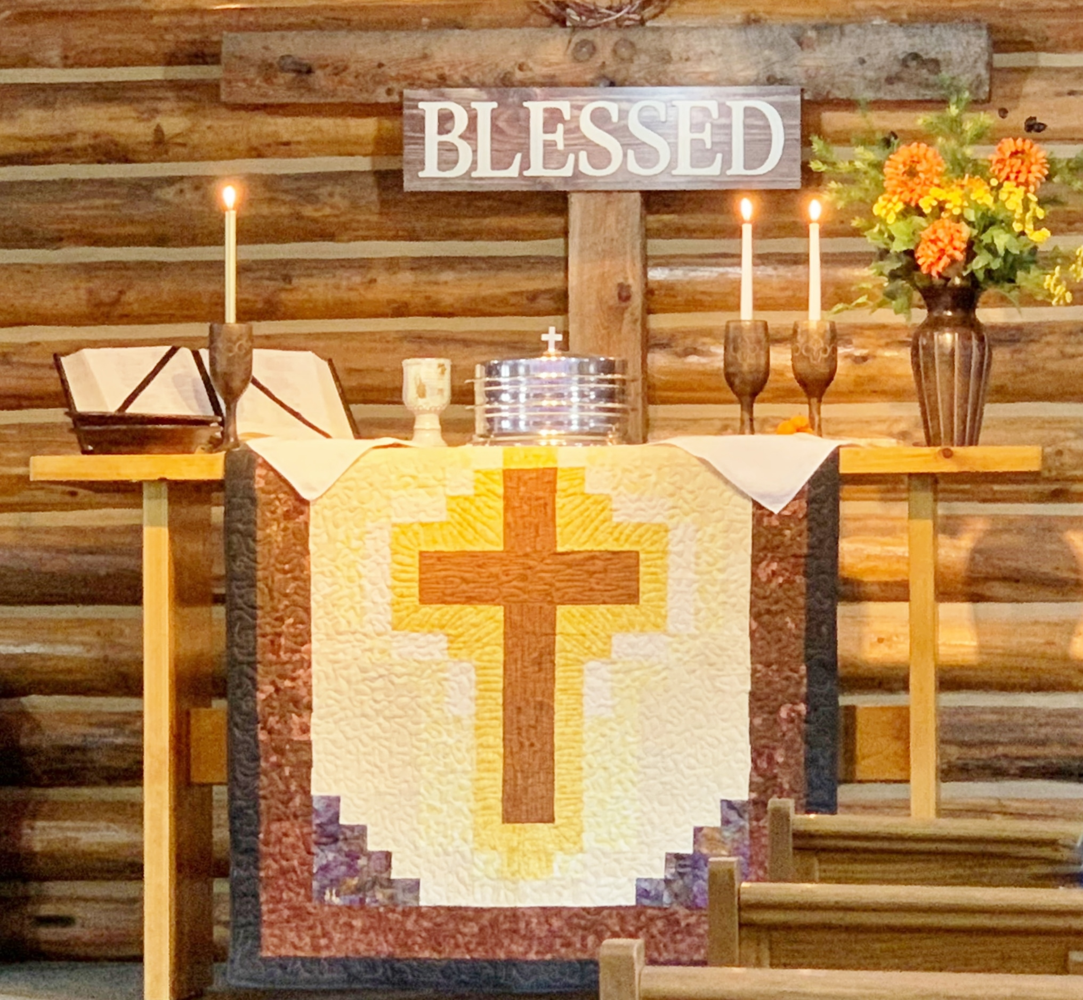  Welcome  Pastor Tom Shanor ~ 208-558-9394  Cell ~ 208-240-2327  www.littlechurchinthepines.org  littlechurchinthepines@hotmail.com  The passion for truth in Scripture is an extension of the passion we have for God.
Little Church in the Pines  Pianist Pam White  Welcome & Announcements  Connie Funkhouser  Call to Worship  (Please stand)  Leader: Come and visit us Lord, give us compassion, mercy, and love.  PPL: In the world where people are rejected, abused, and oppressed, lonely and forgotten.  L: May we step into pray for them, and to help where and when we can in both spiritual and practical ways.  PPL: You LORD taught us in so may of your teachings to take care of those in need.  L: Be they our family, friends, neighbors, and even strangers.  ALL: Help us every hour of every day to be more and more like You Jesus, more like YOU! Amen!  Invocation  “I Want to be More Like You”  Worship Song: Lead by Pastor Tom ~ Please refer to insert  † Blessings and Prayer Request † |  |  | Tithes & Offerings  Ushers Please  Hymn #382 “Doxology ~ Praise to God”  Ephesians 1:3  Hymn #338 “We Sing the Greatness of Our Lord”  Psalm 147:5  “In Jesus Name”  Pastor Tom Shanor  Numbers 13:16  Hymn #352 “Blessed Be the Name”  1 Corinthians 15:25  Communion  Each time we come to Your Table Lord, we recommit  our life, our heart, our thoughts to You.  Insert “The Sweetest Name of All”  Benediction  Hymn #587 “He Keeps Me Singing”  Ephesians 5:19

