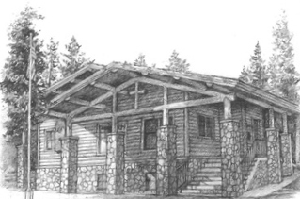  ANNOUNCEMENTS  - Bible Study  (Max Lucado “Experiencing the Heart of Jesus”)  - Ladies of the IP Community/Lots of options for contributing/Humanitarian Relief Fund  - Operation Christmas Child – Shoe Box/Samaritan Purse  - Oct. Breast Cancer Awareness-Tree of Remembrance |  |  | October 17, 2021  Little Church in the Pines  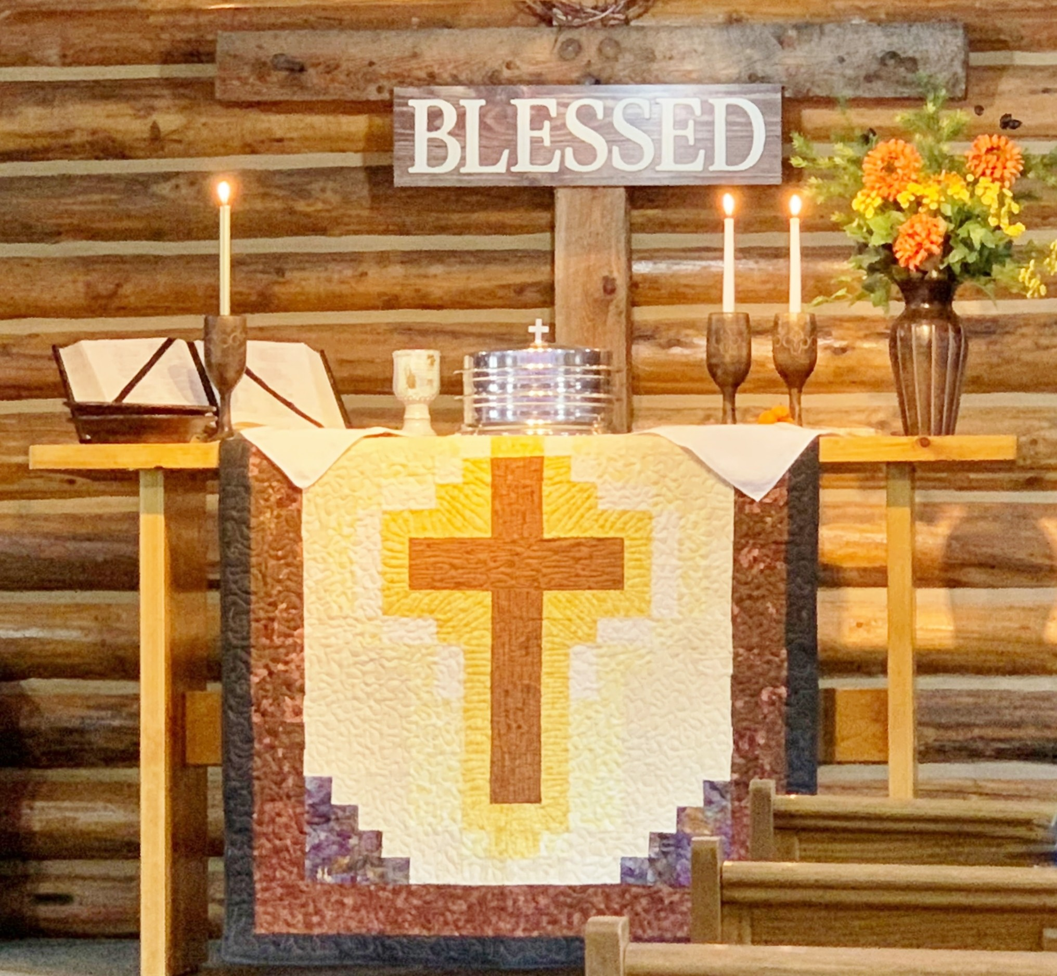  The passion for truth in Scripture is an extension of the passion we have for God.  - Welcome  Pastor Tom Shanor ~ 208-558-9394  Cell ~ 208-240-2327  www.littlechurchinthepines.org  littlechurchinthepines@hotmail.com
Little Church in the Pines  Pianist Pam White  Welcome & Announcements  Connie Funkhouser  Call to Worship  (Please stand)  Leader: Father, we thank You for the privilege of being together this morning at this time and in this place.  PPL: As Your people we pray that Your love will unite us into a deeper fellowship of faith.  Leader: Cleanse us of that would rain our strength and unity.  ALL: Unravel the knots in our spirits. Cleanse the errors of our thinking. Free us from the bondage of our negativity. Break down the barriers that too often keep us apart.  As we move into today’s service . . . kindle within us the fires of Your compassion so that we may further learn to love . . . as You love.  Help us with the knowledge of Your Word, the living Word, Jesus Christ, to reach out to those in need. Break down wall of separation, build bridges of truth and right living.  Let us be Your Alleluia in a broken and fragmented world.  In the Name of our Lord we pray, Amen!  Invocation  Hymn #587 “He Keeps Me Singing”  Ephesians 5:19  † Blessings and Prayer Request † |  |  | Hymn #574 “Revive Us Again”  Psalm 85:6  Tithes & Offerings  Ushers  Hymn #382 “Doxology ~ Praise to God”  Ephesians 1:3  “In the Fulfillment of His Time”  Pastor Tom Shanor  Scripture Reading: Revelation 22:17  Hymn #564 “Let Us Break Bread Together”  Luke 24:30  Communion  Each time we come to Your Table Lord, we recommit  our life, our heart, our thoughts to You.  Hymn #314 “What a Day That Will Be”  Revelation 21:4  Benediction  Hymn #543 “The Family of God”  11 Corinthians 6:16, 18

