- BIBLE REFERENCES IN SERMON  - OLD TESTAMENT  - Chronicles 7:14  - Psalm 9:12 & 10:17  - Psalm 113:6 & 147:6  - Isaiah 57:15  - NEW TESTAMENT  - Romans 12:16  - Philippians 2:8  - James 4:6 & James 4:10  - 1 Peter 5:5 & 6  REMEMBER IN PRAYER  - JoDee Irwin – Circulation  - Mark Irwin - Caregiver  - Chip Drerup – Cancer Recovery  - Kay Drerup - Caregiver  - Kelley Figg – Cancer/Healing  - Linda Harris – Cancer/Comfort  - Susan Tway – Continue Healing  - Rylan – Medical Journey/Cancer  - Dr. Mark Agness – Volunteer in Ukraine  - . . . . .  - . . . . .  - . . . . .  ANNOUNCEMENTS  - Bible Study Friday 9:30 AM – Pastor Tom  - Calendar of Holy Week Services & Summer Events coming soon |  |  | March 13, 2022  Little Church in the Pines  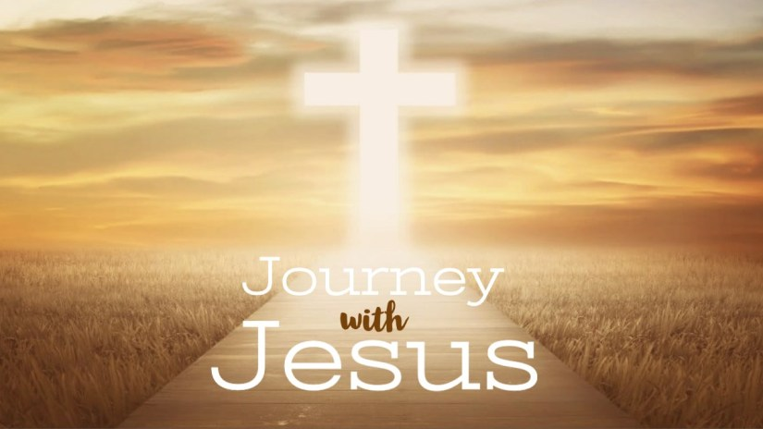  2nd Sunday in Lent  - Welcome  Pastor Tom Shanor ~ 208-558-9394  Cell ~ 208-240-2327  www.littlechurchinthepines.org  littlechurchinthepines@hotmail.com
Little Church in the Pines  Welcome & Announcements  Pianist Pam White  Call to Worship  Connie: The Lord is my shepherd; I shall not want  Ppl: He maketh me to lie down in green pastures and leadeth me beside the still waters.  Connie: He reviveth my soul and guideth me along right pathways for His Name’s sake.  Ppl: For though I walk through the valley of the shadow of death, I shall fear no evil; for You are with me; and Your rod and staff, they comfort me.  Connie: He spreads a table before me in the presence of my enemies.  Ppl: He has anointed my head with oil, and my cup runneth over.  ALL: Surely GOODNESS and MERCY shall follow me all the days of my life, and I will dwell in the house of the LORD forever. Amen!  Invocation  Hymn #363 “To God Be the Glory”  Romans 15:16 |  |  | Blessings and Concerns  Tithes and Offerings  Hymn #382 “Doxology”  “Make Me a Servant”  Insert  2nd Chronicles 7:14  Reading by: George Tway  Humble Thyself in the Sight of the Lord  Sermon: Pastor Tom Shanor  James 4:5-10 KJV  Reading by: Pam White  Hymn #84 “My Faith Looks Up to Thee”  John 6:68  Communion  Each time we come to Your Table Lord, we recommit our life, our heart, our thoughts to You.  Hymn #408 “I Surrender All”  John 12:25  Benediction ~ “Amazing Grace”  Video

