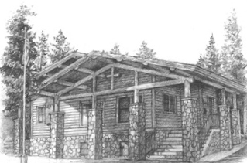  ANNOUNCEMENTS  - Tues. Aug. 2 Ladies of the IP Community 11am meet here.  - Aug. 4, Thurs. 6:30pm EMS Building– Jason Coombs Helping our Loved Ones on the Path to *Addiction Recovery*  - Mon. Aug. 8 Daisy’s Angels’ Strawberry Lemonade Fashion Show, Luncheon & Boutique  - Aug. Aug. 13, 9am-12pm SWAPTASTIC EMS Building (Drop off Aug. 4 12-4pm)  - Aug. 13, 7pm LDS Church/Art Show by Christian Artist Kate Lee  - Aug. 19 LCIP BBQ 5:30pm  - Aug. 27 LCIP Pancake Breakfast 8am-10:30am  - Bible Study Friday 9:30 AM “Experiencing the Heart of Jesus” – Pastor Tom  - Hopefully, next Sat. Shafer Farmers will be hosting their Farmers Market in front of Connie’s. |  |  | July 31, 2022 ~ Happy Birthday, Sunday!  Little Church in the Pines  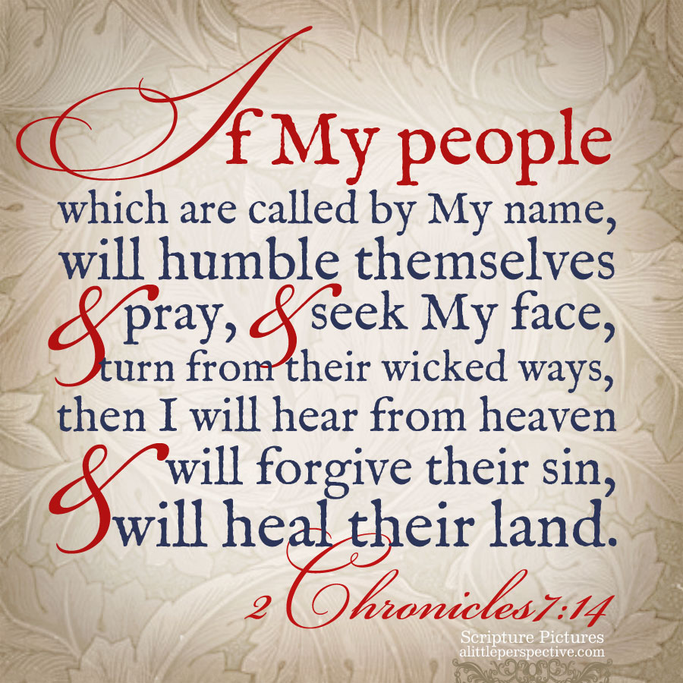  Welcome  Pastor Tom Shanor  littlechurchinthepines@hotmail.com  Cell ~ 208-240-2327  www.littlechurchinthepines.org  littlechurchinthepines@hotmail.com
Little Church in the Pines  Welcome & Announcements  Call to Worship  ** Please Stand **  Leader: God, You are ever pursuing, ever loving and ever caring.  Ppl: We count ourselves grateful and thankful that Your love for us is deep and everlasting.  Leader: May Your children praise You, O God: may all the peoples on earth praise You for Your faithfulness to us.  Ppl: Let us be glad and sing for JOY!  Leader: For Your promised to never leave or abandon us.  Ppl: May our hearts be filled with JOY for evermore.  ALL: We bow down, and we worship You Lord, we bow down and we worship You Lord, King of all kings You will be! Amen!  Invocation  Hymn #5 “Morning Has Broken”  Psalm 118:24  Shared Blessings & Prayer Requests  Tithes and Offerings  Hymn #382 “Doxology” |  |  | Hymn #377 “Joyful, Joyful, We Adore Thee”  Malachi 4:2  Tithes and Offers Hymn #382  “Praise God, from All Blessings Flow”  “God in Pursuit of You, Us”  (The Hound of Heaven)  Sermon by; Pastor Tom Shanor  Hymn #667 “Jesus Saves”  Luke 15:7  Communion  Christ has DIED, Christ has RISEN, and  Christ will COME AGAIN!  Hymn #681 “Let There Be Peace on Earth”  John 14:27  Benediction  Lorrie Robb  God Be with You until We Meet Again

