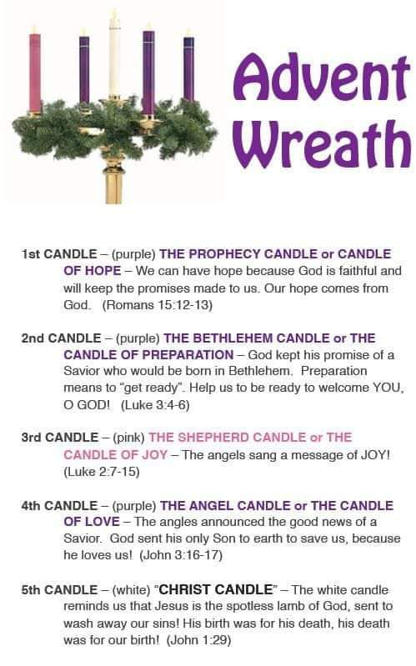  ANNOUNCEMENTS:  - Tues: Volunteers are needed! IPLCOR Event  - IP Ladies Community Outreach Meeting has been moved to Wed. 11am  - Bible Study, Friday 9:30am, Philippians  - Friday, Dec. 9 6:00pm Community Christmas Party LDS Chapel. This is an interdenominational event.  - A Special Christmas Eve Service Saturday, Dec. 24 7pm  - Visit our website for 2023 Calendar of Events  THANK YOU * THANK YOU TO THE BEYOND FABULOUS VOLUNTEERS DAISY’S ANGELS CHRISTMAS FESTIVAL |  |  | December 4, 2022  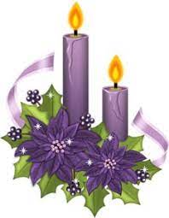 Welcome  Pastor Tom Shanor ~ 208-558-9394  Cell ~ 208-240-2327  www.littlechurchinthepines.org  littlechurchinthepines@hotmail.com  Little Church in the Pines
Little Church in the Pines  Pianist Pam White  Welcome & Announcements  Connie Funkhouser  Call to Worship  Larry and Joyce Johnson  Please Stand  Leader: Though many places in the world are bound in war,  Ppl: The peace of God is poured out for all people.  L: Though discord and struggle have become factors in the lives of the people,  Ppl: The love of God is lavished on all people.  L: Let us praise the God of Love and Peace.  Ppl: Let us listen for God’s words of Peace and justice for all people. Amen!  Please be seated  Advent Reading &  Lighting the Candle of Peace  Larry & Joyce Johnson  Invocation  Hymn #494 “Wonderful Peace”  Philippians 4:7 |  |  | Blessings and Prayer Request  Tithes & Offerings Hymn #382 “Doxology”  Hymn #495 “It Is Well with My Soul”  Psalm 49:15  “The Gift of Peace”  2nd Sunday of our Advent Journey  Hope becomes Peace  Connie Funkhouser – An Apprentice of Jesus Christ  “Sweet Little Jesus Boy”  Special Music by: Louise Neal  Communion  Each time we come to Your Table Lord, we recommit our life, our heart, our thoughts to You.  Hymn #681 “Let There Be Peace on Earth”  John 14:27  Benediction

