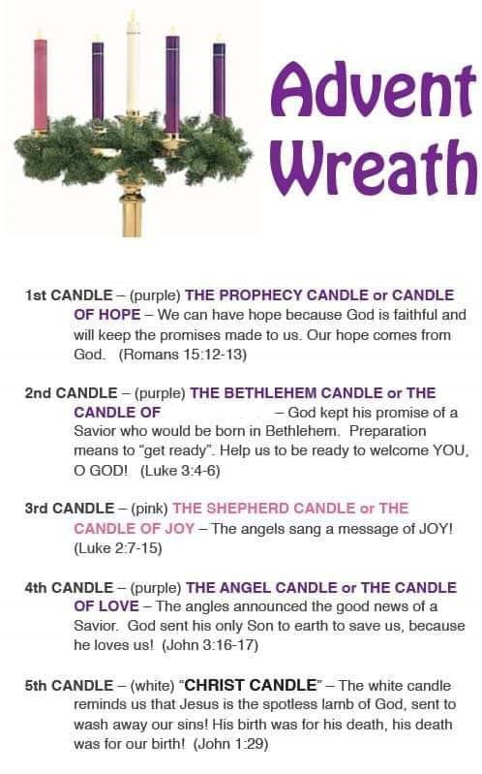  As we anticipate Christmas, let us remember the birth of the Prince of Peace. (Isaiah 9:6)  PEACE  ANNOUNCEMENTS  - Bible Study on hold till 01/06/2023 9:30am Philippians 3:12  - Saturday, Dec. 24 7pm LCIP Christmas Eve Service  - NO CHURCH SERVICE SUNDAY, DEC. 25 | LITTLE CHURCH in the PINES | Little Church in the Pines | 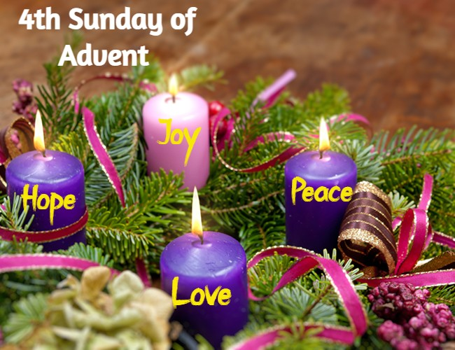  December 18, 2022  - Welcome  Pastor Tom Shanor ~ 208-558-9394  Cell ~ 208-240-2327  www.littlechurchinthepines.org  littlechurchinthepines@hotmail.com
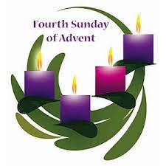  Little Church in the Pines  Pianist Pam White  Welcome & Announcements  Connie Funkhouser  Call to Worship  Yeuleta Bradley  Leader: Your Love, Lord, reaches to the heavens.  Ppl: Your faithfulness to the skies.  Leader: Your righteousness is like the highest mountains.  Ppl: Your justice like the great deep.  Leader: You, Lord, preserve our lives.  Ppl: How priceless is your unfailing love, O God!  Leader: People take refuge in the shadow of Your wings.  Ppl: We celebrate Your incredible love today. Amen!  LIGHTING THE ADVENT  CANDLE of LOVE  Yeuleta Bradley & Constance Rae Day  Invocation  Hymn #193 “O Come All Ye Faithful”  Luke 2:15 |  |  | Blessings and Concerns  Hymn #199 “Redeeming Love”  Isaiah 53:4  Tithes & Offerings Hymn #382 “Doxology”  Ushers Yeuleta Bradley & Constance Rae Day  “The Greatest Gift”  1 Corinthians 13  Pastor Tom Shanor  Hymn #13 “The Wonder of it All”  Ephesians 2:10  Communion  Each time we come to Your Table Lord, we recommit our life, our heart, our thoughts to You.  Hymn #171 “Joy to the World”  Luke 2:11  For unto you is born this day . . . a Savior . . . .  Benediction

