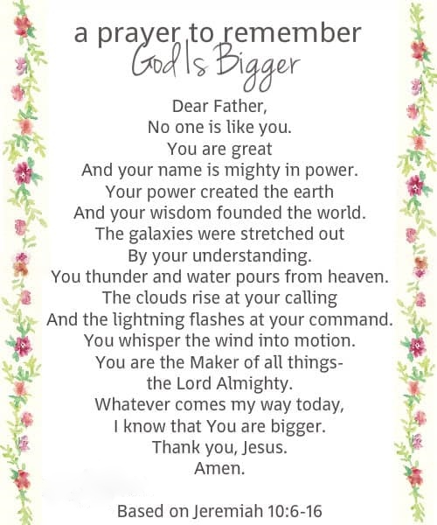  ANNOUNCEMENTS  - Bible Study Friday 9:30am  - AA Meetings 7pm Tues & Sat. outside around the firepit  - Thurs. Aug. 26 Ashton Community United Methodist Church Steak Fry 5-7pm  - Shaffer Farms Outdoor Market – Saturdays 11am  - Pancake Breakfast Saturday, Aug. 28 8am  - Steering Committee Annual Meeting Aug. 29  - Sept. 17, Fri. End of Summer BBQ 5pm |  |  | August 22, 2021  Little Church in the Pines  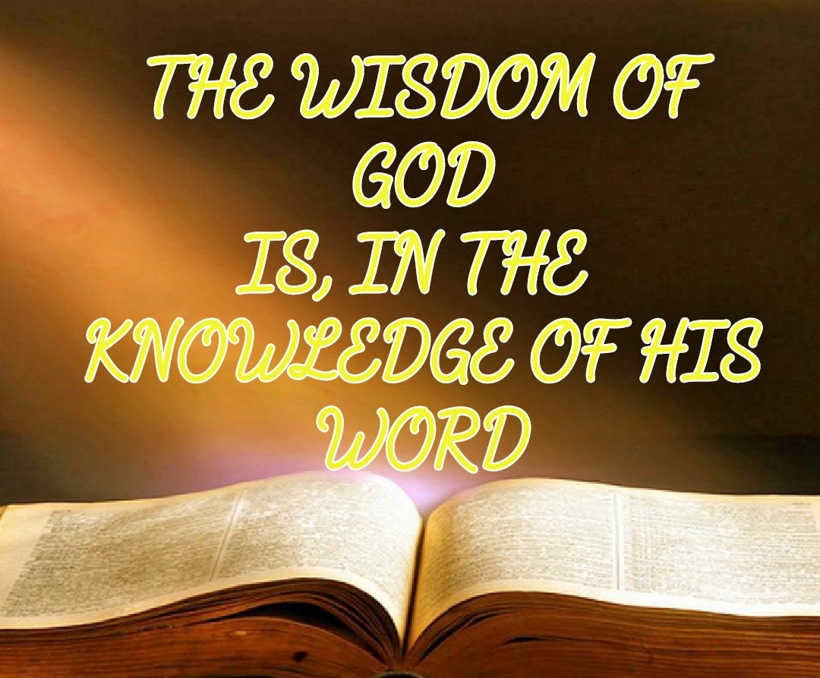  - Welcome  Pastor Tom Shanor ~ 208-558-9394  Cell ~ 208-240-2327  www.littlechurchinthepines.org  littlechurchinthepines@hotmail.com
Little Church in the Pines  Pianist Pam White  Welcome & Announcements  Connie Funkhouser  Call to Worship (PLEASE STAND)  Julie Newsome  Psalm 34  Leader: I will bless the Lord at all times.  Ppl: His praise shall continually be in my mouth.  Leader: The humble shall hear of it and be glad.  Ppl: O magnify the Lord with me.  Leader: And let us exalt His name together.  Ppl: I sought the Lord and He heard me.  Leader: And He delivered me from all my fears.  Ppl: They looked to Him and were radiant.  Leader: And their faces were not ashamed.  Ppl: The poor man cried out, and the Lord saved him.  Leader: And saved him out of all his troubles.  Ppl: The angel of the Lord camps all around those who fear Him, and He delivers them.  All: O taste and see that the Lord is good; blessed are those who trust in Him! Amen!  Invocation  Hymn #82 “Victory in Jesus”  1 John 5:4 |  |  | Blessings and Concerns  Hymn #472 “Teach Me Your Way, O Lord”  Psalm 25:4,5  Tithes & Offerings Hymn #382 “Doxology”  Larry & Joyce Johnson  Hymn #443 “I Need Thee Every Hour”  Matthew 6:8  Scripture Reading Proverbs 16:18  Pam White  By Pride Comes Nothing but Strife, but with the  Well Advised Comes Wisdom Proverbs 13:10  Pastor Tom Shanor  Communion  Each time we come to Your Table Lord, we recommit our life, our heart, our thoughts to You.  Hymn #544 “The Bond of Love”  Jon 13:35  Benediction

