- BIBLE REFERENCES IN SERMON  - OLD TESTAMENT  - Psalm 63: 1-8  - Isaiah 55: 1-9  - NEW TESTAMENT  - 1 Corinthians 10: 1-13  - Luke 13: 1-9  REMEMBER IN PRAYER  - JoDee Irwin – Circulation  - Mark Irwin – Husband/Caregiver  - Chip Drerup – Cancer Recovery  - Kay Drerup – Wife/Caregiver  - Kelley Figg – Cancer/Healing  - Linda Harris – Cancer/Comfort  - Susan Tway – Continue Healing  - Rylan – Medical Journey/Cancer  - Dr. Mark Agness – Volunteer in Ukraine  - Greg Neal – Continue Healing  - Louise Neal – Wife/Caregiver  - April Byerhof – Family/Travels  - . . . . .  - . . . . .  - . . . . .  ANNOUNCEMENTS  - Bible Study Friday 9:30 AM – Pastor Tom “Knowing the Heart of Jesus” by Max Lucado  - Calendar of Holy Week Services & Summer Events **Please Visit Our website** |  |  | March 20, 2022  Little Church in the Pines  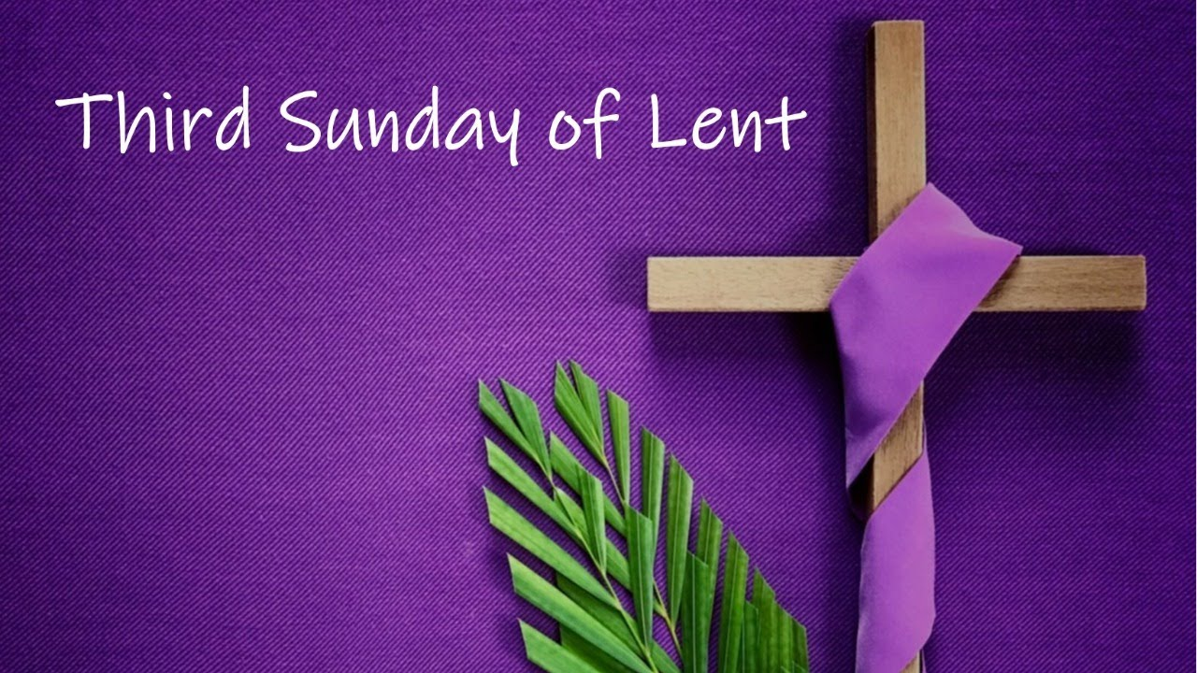  ~ First Day of Spring ~  - Welcome 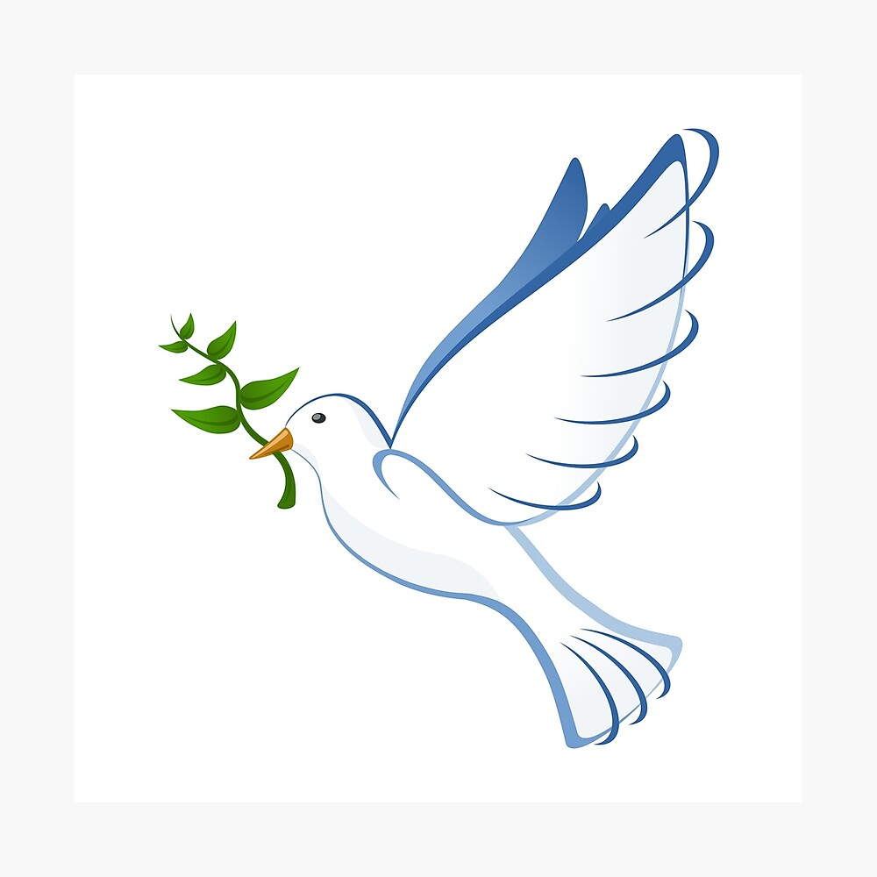  Pastor Tom Shanor ~ 208-558-9394  Cell ~ 208-240-2327  www.littlechurchinthepines.org  littlechurchinthepines@hotmail.com
Little Church in the Pines  Welcome & Announcements  Pianist Pam White  Call to Worship  Connie: Have mercy on me, O God, according to Your loving kindness, in Your great compassion, erase my offenses.  Ppl: Wash me through and through from my sinfulness, and cleanse me according to Your great mercy.  Connie: I know my transgressions and my sin is ever before me. Against You.  Ppl: and so, You are justified when You speak, and upright in Your judgment.  Connie: Indeed, I have sinned since my birth, from my mother’s womb.  Ppl: For behold, You look for truth deep within me, and You will help me to understand wisdom You placed within me.  Connie: Make me hear of joy and gladness, that the body You have broken may rejoice.  ALL: Create in me a clean heart, O LORD, and renew a right spirit within me. Amen!  Invocation  Hymn #439 “Sweet Hour of Prayer”  Acts 3:1 |  |  | Blessings and Concerns  Special Music  “He Touch Me”  Larry & Joyce Johnson & Pastor Connie Day  Tithes and Offerings Hymn #382 “Doxology”  “As the Deer”  Insert  Isaiah 55:1-9  Psalm 63: 1-8  ^{“O God, You, are my God”}  Sermon: Pastor Tom Shanor  Hymn #436 “For those Tears I Died”  John 4:14  Communion  Each time we come to Your Table Lord, we recommit our life, our heart, our thoughts to You.  Hymn #681 “Let There be Peace on Earth”  John 14:27  Benediction

